MECHANICAL DESIGN MANUAL SUMMARY SHEET

SUBJECT: Heat Exchangers

DESCRIPTION: Description of Heat Exchangers

SPEC SECTION: 15755

APPLICABLE
REFERENCES: ASHRAE 2000 Handbook – HVAC Systems and Equipment Chapter 43
ASHRAE 2004 Handbook - HVAC Systems and Equipment
Chapter 11

DATE: November 8, 2004

PREPARED BY: Brent M. Husser

Introduction:

Heat exchangers are common in the HVAC industry for heating water systems, domestic hot water systems, chilled water systems, and processes. Heat exchangers are devices in which fluid streams exchange energy without contacting each other. Heat exchangers commonly exchange sensible and latent heat. Sensible heat transfer occurs between two liquids, while a latent heat transfer occurs when a vapor is condensed into a liquid. Steam is a common heating medium for latent heat transfer. There are various types of heat exchangers that can be used for different applications. This design manual will discuss the two most common types of heat exchangers; shell and tube and plate and frame.

Shell-and-Tube Heat Exchanger:

Description:

- Shell-and-tube heat exchangers are one of the most commonly used heat exchangers in HVAC designs. A tube bundle that transports one fluid is encased by a tubular shell that holds the other fluid. One fluid enters the top of the shell and exits the bottom, while the other fluid is routed through the U-tubes at the header. Shell-and-tube heat exchangers typically use steam to heat a liquid. This is because the inability to clean the shell and the lack of counterflow movement are not disadvantages with condensing steam. There are several different configurations for shell-and-tube heat exchangers, the most common being a U-tube design.
- The U-tube design incorporates the tube bundle with 180° bends in the tubes. This makes it inexpensive and able to withstand expansion and contraction, but also makes it difficult to clean the tube interiors. The entire tube bundle can be removed to clean the exterior of the tubes. This style is especially effective as a “converter” or steam-to-water heat exchanger because cleaning of closed-system tubes is rarely needed. The connections for the heated medium are typically at the same end. Other configurations are counterflow, straight tube (straight tube models are used when cleaning the tube interiors is important), and shell-and-coil designs. See Figure 1 for an example of a counterflow heat exchanger. Notice the fluid to be heated enters at the end where the heating medium exits, creating the counterflow concept. The bolted header can be removed so the tube bundles can be cleaned. During design, be sure to designate space for the tubes to be pulled and cleaned (typically the length of the heat exchanger).
- U-tube heat exchangers can be used in domestic hot water heaters. The U-tube is inserted within a storage tank, with the header located outside the tank. Steam or water is routed into the header, through several tube passes, and out the outlet connection. The tank and U-tube design are most common in older buildings. Most new domestic hot water systems do not have the heat exchanger inside the storage tank. When using a heat exchanger for domestic water purposes, a double wall exchanger should be used to prevent the introduction of steam treatment chemicals into the domestic water system. If a single wall heat exchanger is used, be sure the water pressure is always higher than steam pressure using a pressure gradient system and verify any other requirements with local plumbing codes and AHJ. See Bell & Gossett’s Model TCW for further details of a “tank heater” design.

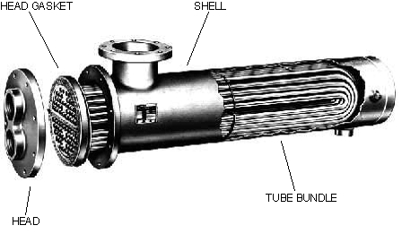
FLUID TO BE HEATED INLET

FLUID TO BE HEATED OUTLET

HEATING MEDIUM INLET

HEATING MEDIUM OUTLET

Figure 1. Counterflow Shell-and-Tube Heat Exchanger

Piping Configurations:

- If the heat exchanger is using steam for the heating medium, the steam connection will be on the top of the shell and the condensate connection will be at the bottom to allow drainage.
  - Be sure to specify a mounting height for the heat exchanger to allow for:
    - Proper height for the steam traps to be installed.
    - Proper height for the condensate to gravity drain to a condensate transfer station.
  - When selecting a heat exchanger, be sure to coordinate the heat exchanger steam pressure with the pressure downstream of the control valve. Control valves can have a very high pressure drop. The designer should coordinate allowable pressure drops with the control valve specifications.
  - Two float and thermostatic condensate traps will typically be used to serve shell-and-tube heat exchangers. Refer to the steam trap design manual for further information.
  - There are often two modulating steam control valves serving the heat exchanger. Usually a 1/3-2/3 configuration is used. If there is a low steam demand, the 1/3 control valve will operate. As there is more demand and the 1/3 valve can no longer maintain setpoint, the 1/3 valve closes and the 2/3 valve opens. If setpoint still cannot be maintained, both valves modulate open. The opposite occurs as demand drops. Coordinate the flow diagram control valves with the control specifications.
- See Figure 2 below for a typical shell and tube heat exchanger piping schematic.

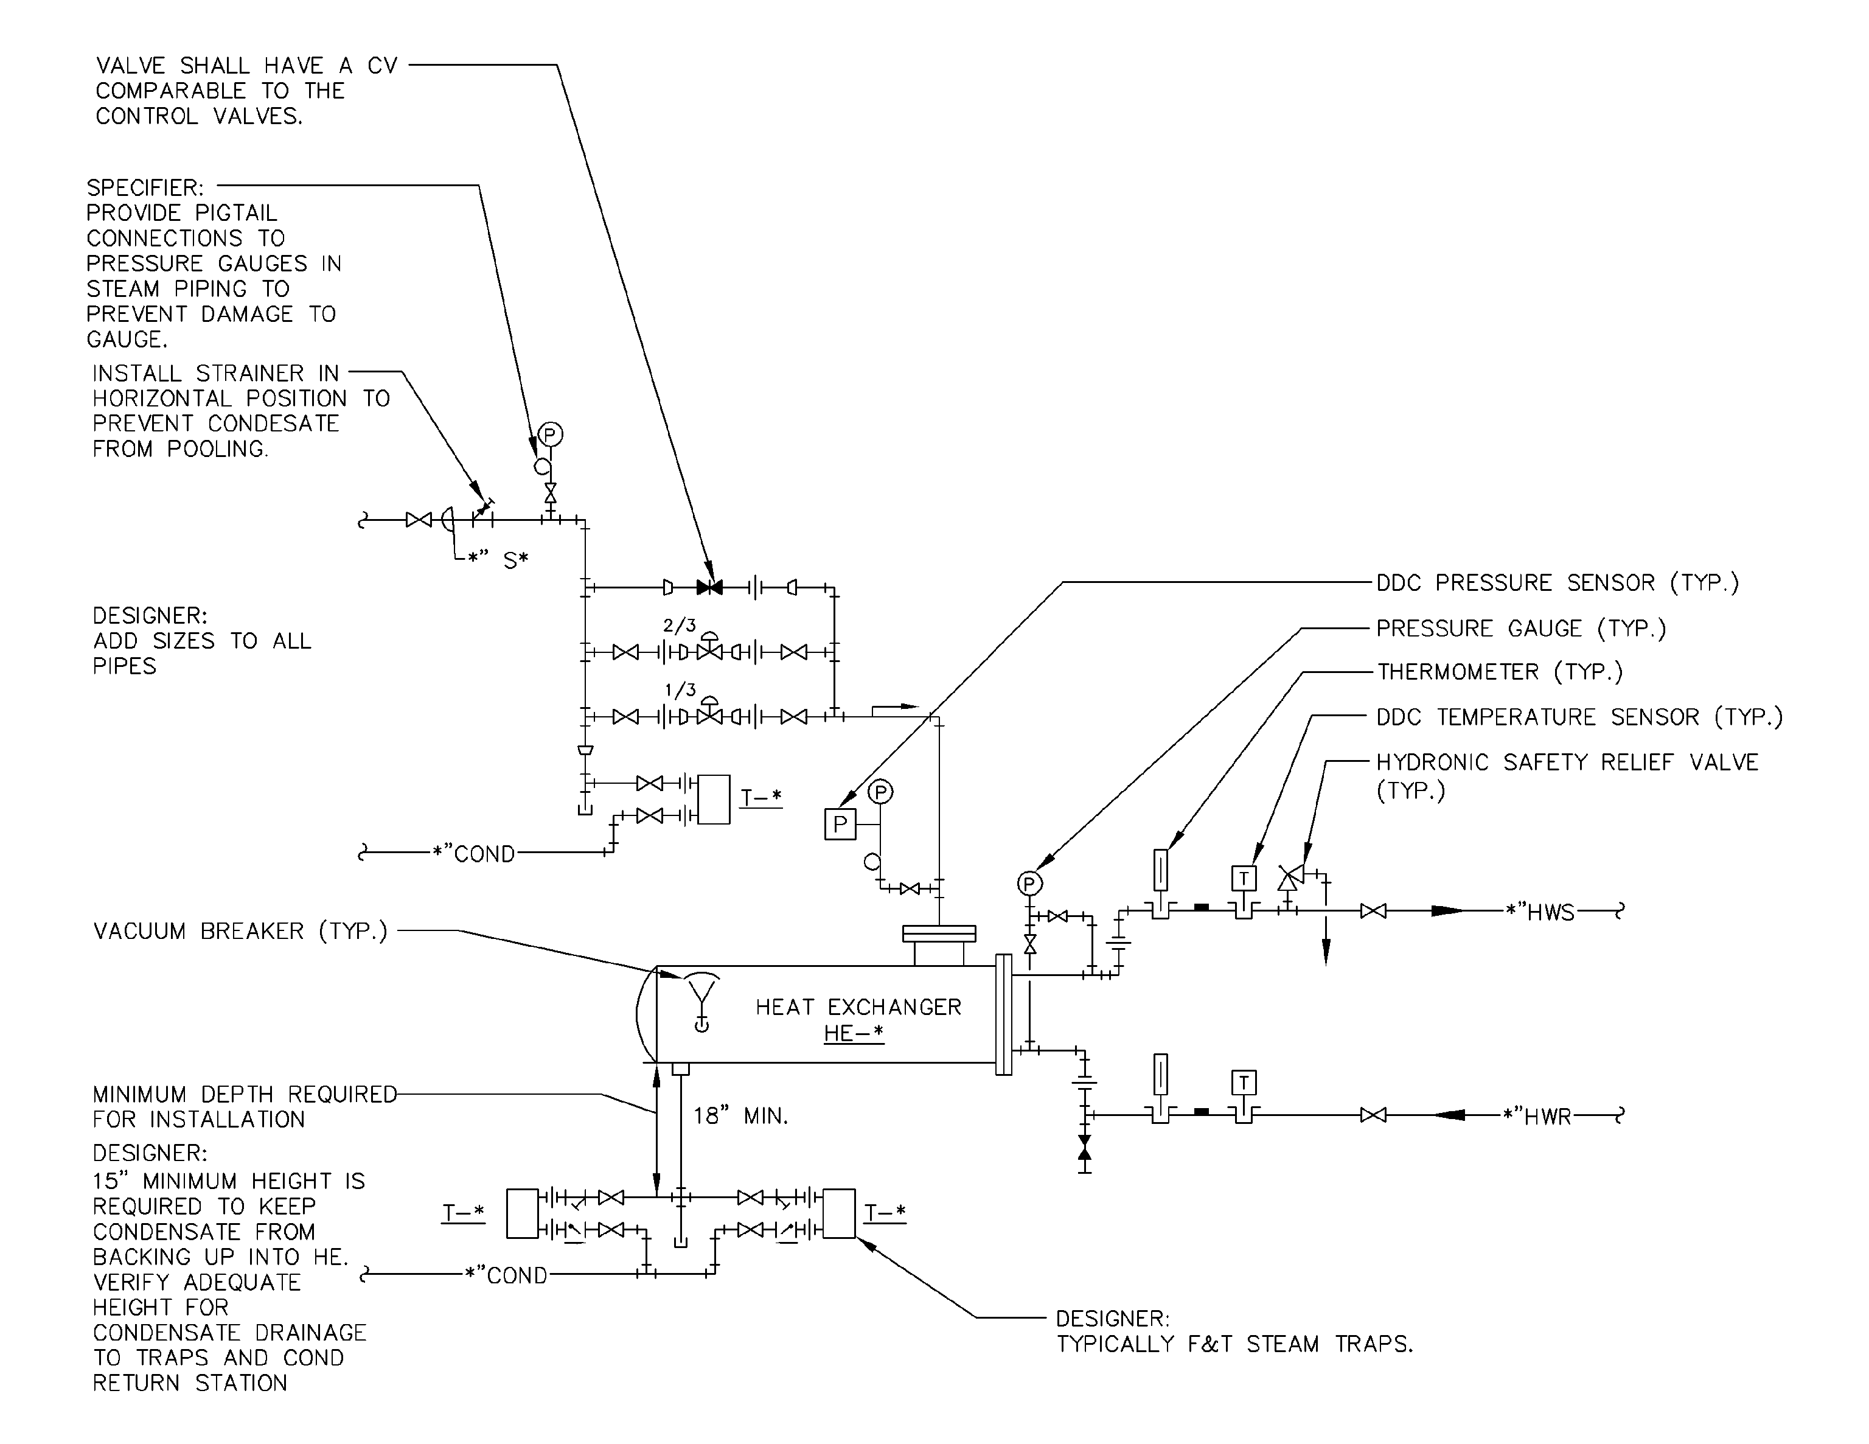

Figure 2. Shell-and-Tube Heat Exchanger Piping Configuration (Steam-to-water)

Advantages/Disadvantages:

- Shell-and-tube heat exchangers are very dependable. Since there are no moving parts and few gaskets, the equipment life is usually long.
- Only annual maintenance of cleaning tubes is required.
- Heat exchangers can be installed and mounted almost anywhere, though they should be accessible for cleaning and pulling tubes if repair is needed.
- Control of the heat exchangers is simple.
- Heat exchangers can take up quite a bit of space once the pull space and proper heights for gravity draining condensate are figured. During design, the length and diameter of the heat exchanger can be altered to best fit the space requirements.

Shell-and-Tube Heat Exchanger Selection Criteria (assume steam to water application for hydronic system):

- Define the entering and leaving water temperatures required. KJWW typically designs to 150/180°F water temperatures, but a 20°F delta T is also common. The larger the delta T, the less water flow will be required for the same amount of heat in the coils, reducing pump flow, piping size, etc.
- Select shell-and-tube heat exchangers that are factory standards, if possible, to help reduce the cost of the equipment. In general, adding length is cheaper than increasing diameter.
- Define the fouling factor for the exchanger. The fouling factor is assigned to provide excess surface area to account for water quality and scaling, which, over time, will reduce the efficiency of the exchanger. KJWW typically utilizes a fouling factor of 0.0001, but this should be verified for the design conditions.
- Calculate the steam load required to heat the water as previously defined.
- Consider a backup heat exchanger in critical areas where heating cannot be down for maintenance.
- Select heat exchanger at 0 psig for heating systems operating at 15 psig or less.

Plate and Frame Heat Exchanger:

Description:

- Plate and frame heat exchangers consist of welded, brazed, or gasketed plates arranged to provide a counterflow heat exchange between two fluids. The plates are fixed together between end plates and hung on a frame. When the plates are fixed together, they create spaces between the plates that provide a path for fluid flow. There are four parallel channels that supply and return fluids to and from the plates. The fluid runs up or down this space between the plates, creating heat transfer across the plate. The flow of the two fluids occurs in a counterflow pattern. The carrying bar, or the top and bottom bar from which the plates hang, dictates how many plates can be utilized by a heat exchanger. KJWW typically specifies a gasketed heat exchanger with a carrying bar 50% longer than required with all connections on the fixed end so plates can be added in the future. Gasketed plate and frame heat exchangers can be disassembled and cleaned for maintenance, while welded or brazed exchangers cannot. Plate and frame heat exchangers are not typically used with steam and are more common with liquid-to-liquid applications. This is largely because counterflow heat exchange is not a significant benefit with condensing fluids. See Figure 3 for an example of a plate and frame heat exchanger.
- Welded or brazed plate and frame heat exchangers are typically used when dealing with fluids that are not compatible with gasket materials, such as high pressure applications or ammonia refrigeration. Gasketed plate and frame heat exchangers are used when maintenance is required. They are suitable for steam, vapor, or water solutions and feature a close approach temperature. Depending on the material used for welding, the welded or brazed exchangers offer a cost savings but are impossible to maintain.
- Double wall plate and frame heat exchangers have an air space built between each pair of plates. If a leak occurs, the fluid will leak to the exterior of the exchanger, preventing cross-contamination between fluids. Double wall exchangers are normally required when dealing with domestic hot water systems.

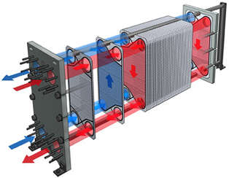
Figure 3. Gasketed Plate and Frame Heat Exchanger

Piping Configurations:

- The piping on the plans and flow diagram should reflect the counterflow design and realistic connections.
- Provide space for maintenance. Refer to Figure 3.
- See Figure 4 below for a typical plate and frame heat exchanger piping schematic.

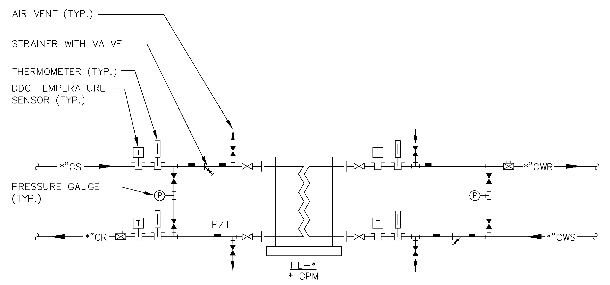

Figure 4. Plate and Frame Heat Exchanger Piping Configuration

Advantages/Disadvantages:

- Plate and frame heat exchangers offer a high ratio of heat transfer surface area to floor space required for the equipment installation. In water-to-water applications with close approaches, plate and frame heat exchangers offer much smaller footprints than shell and tube heat exchangers.
- Annual maintenance can be tedious and time consuming with gasketed plate and frame heat exchangers since each plate is removed and scrubbed. This may be required if the plate and frame heat exchanger is connected to an open system without filtration (free cooling application). However, maintenance cleaning is often minimal due to the high fluid velocities between the plates.
- Pumps are required for both fluids.
- A plate and frame heat exchanger can be designed for a “temperature cross”. A temperature cross occurs when the exit temperature of the heating fluid is lower than the exit temperature of the fluid being heated.
- Plate and frame heat exchangers can produce close approaches much more economically than shell and tube exchangers.
- Plate and frame heat exchangers can also operate using varied flow but verify the minimum flow rate needed is adequate to maintain the Reynolds number needed for predictable heat exchange rates. Plate and frame heat exchangers require turbulent flow for good heat transfer.
- Typically plate and frame heat exchangers cost more.

Plate and Frame Heat Exchanger Selection Criteria:

- The heat exchanger is divided between a “hot side” and a “cold side”. In order to select a plate and frame heat exchanger, three out of the four following variables need to be known: flow for the hot side fluid, flow for the cold side fluid, temperature for the hot side fluid, and temperature for the cold side fluid. The two flows do not have to be the same and may vary. Using the same flows gives the designer a good starting point in selections. A sales representative can easily run a selection to find the unknown performance values, such as the unknown fluid temperature, pressure drops, quantity of plates, heating surface required, etc. The flows through the heat exchangers can vary. Further discussions with the equipment manufacturer should take place when selecting the heat exchanger.

Applications:

Various heat exchanger types are better suited for different applications. The shell-and-tube heat exchangers are typically used for the following applications:

- Any system using steam as a heating medium.
- Domestic water heaters.

The plate and frame heat exchangers are typically used for the following applications:

- “Free cooling” in chilled water applications.
- Process applications.
- Any liquid-to-liquid application, especially if close approach is needed.

